**Course Methods Year 12**

Student name: ________________ Teacher name: ________________

Date: 14 Feb

**Task type: Response**

**Time allowed for this task: _____45______ mins**

**Number of questions: _____8______**

**Materials required:** Calculator with CAS capability (to be provided by the student)

Standard items: Pens (blue/black preferred), pencils (including coloured), sharpener, correction fluid/tape, eraser, ruler, highlighters

Special items: Drawing instruments, templates, notes on one unfolded sheet of   
A4 paper, and up to three calculators approved for use in the WACE examinations

**Marks available: __47____ marks**

**Task weighting: __10__%**

**Formula sheet provided: Yes**

**Note: All part questions worth more than 2 marks require working to obtain full marks.**

**Q1 (3.1.7) (9 marks)**

Use the product rule and/or quotient rule to differentiate the following.(Simplify)

Note: Zero marks for answer only here.

1.  (3 marks)
2.  (3 marks)
3.  (3 marks)

**Q2 (3 marks)**

Determine the equation of the tangent to  at the point .

**Q3 (3.1.8) (8 marks)**

Consider the functions and their derivatives with values given for the following x values.

|  |  |  |  |
| --- | --- | --- | --- |
| X value | -1 | 3 | 7 |
|  | 5 | 2 | -4 |
|  | 0 | 1 | -2 |
|  | 2 | 5 | -3 |
|  | -1 | -2 | 6 |

Determine the **derivatives** of the following at the given x values.’

1.  at  (2 marks)
2.  at  (3 marks)
3. at  (3 marks)

**Q4 (3.1.14, 3.1.15) (7 marks)**

Use calculus techniques to determine the **exact** coordinates of any stationary points on the following curves and use the second derivative test to determine the nature of the stationary point.

1.  (3 marks)
2.  (4 marks)

**Q5 (3.1.12) (7 marks)**

The displacement of a body from an origin O, at time  seconds, is  metres

where , .

Determine the following.

1. The velocity function. (2 marks)
2. The times and displacements when the body is at rest. (3 marks)
3. The distance travelled in the first 12 seconds. (2 marks)
4.  and explain its meaning. (2 marks)

**Q6 (3.1.10) (3 marks)**

If  use the small increments formula  to determine the approximate percentage change in  when  decreases by .

**Q7 (3.1.11) (6 marks)**

A colony of bacteria is represented as a circle on a petri dish and is increasing in such a way that the number of bacteria present is given by  where ,  being the radius of the circle of bacteria.

1. Determine  and explain its meaning. (3 marks)
2. Determine  and explain its meaning. (3 marks)

**Q8 (3.1.16) (4 marks)**

Consider a **closed** hollow cylinder with end radius metres and length  metres.

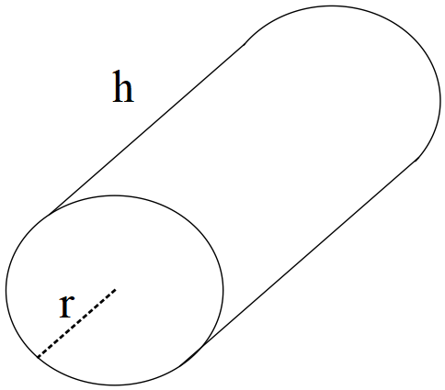

If the outside of the closed cylinder has a surface area of  determine the dimensions of the radius and length, nearest cm, to maximise the capacity of the cylinder using calculus techniques.

**Extra working space**

**Extra working space**